Warrior Ambassador Awards - New Inductees

The Warrior Ambassador Awards were established in 2013 to acknowledge all contributors (past, present and future) who have supported Wheatbelt Men’s Health (Inc.) and The Regional Men’s Health Initiative.

The Warrior Ambassador Awards specifically aim to:
  - Acknowledge the wide range of contributors to WMH and/or RMHI;
  - Develop and foster relations with past and present individuals and/or organisations who contribute to WMH and/or RMHI;
  - Establish a network of champions for the cause to further promote regional men’s health and wellbeing through WMH and/or RMHI.

We currently have 35 Warrior Ambassadors under the categories of Pioneer, Open, Personal Stories and Fundraising.

On the 3rd August 2018 at the Rose & Crown in Guildford, five new Warrior Ambassadors were inducted and acknowledged under the Fundraising Category. These were:
- MEEDAC
- Social Dance Group Inc.
- SSAA Western Australia
- Gate 2 Plate Challenge
- The Rusty Coights Rickshaw Run

The support we receive from organisations and individuals such as those we have recognised in the past and today is critical to the success of our organisation and the programs we deliver. The RMHI wouldn’t reach and impact so many blokes without your valued contribution.
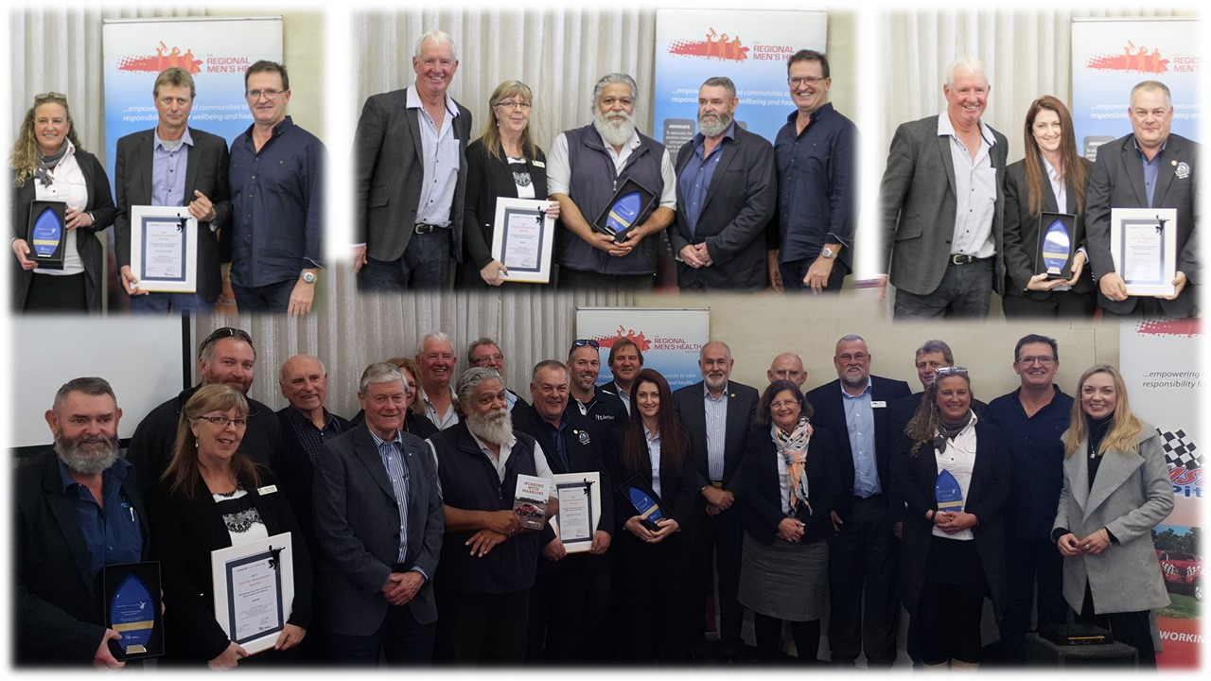

The Regional Men’s Health Initiative
delivered by Wheatbelt Men’s Health (Inc.)
PO Box 768, Northam WA 6401
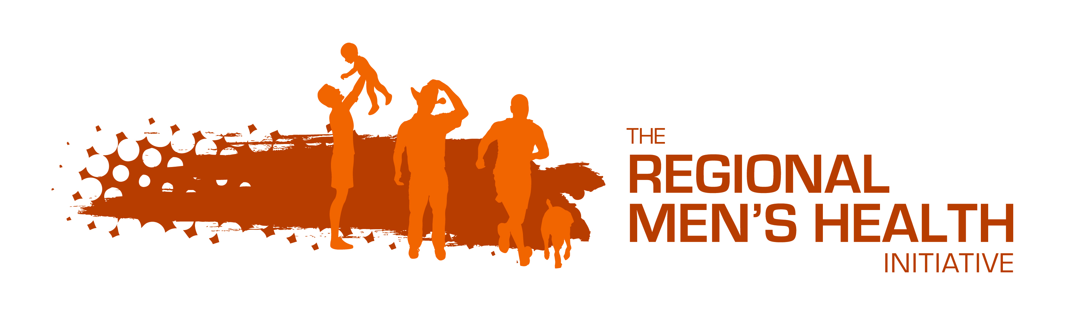
Phone: 08 9690 2277
Email: menshealth@4blokes.com.au
www.regionalmenshealth.com.au

